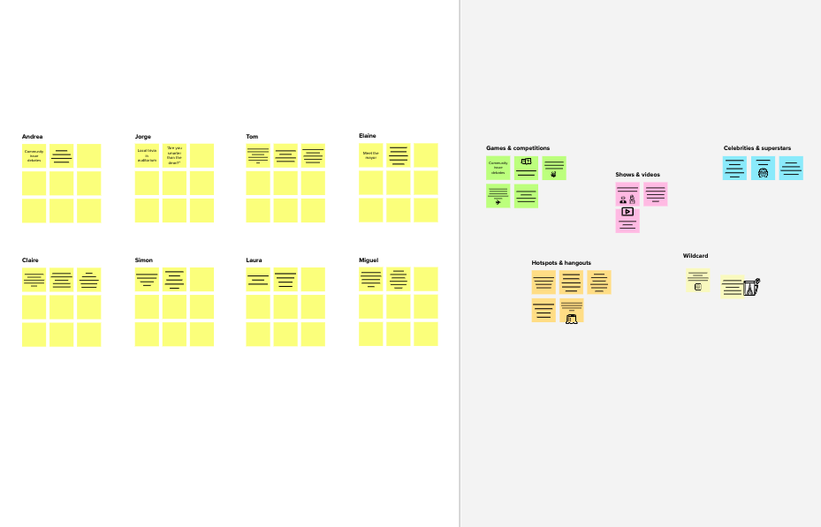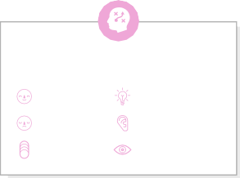

# Brainstorm

**TIP**

You can select a sticky note and hit the pencil [switch to sketch] icon to start drawing!

## Before you collaborate

A little bit of preparation goes a long way with this session. Here’s what you need to do to get going.

**10 minutes**

**1**

## Define your problem statement

What problem are you trying to solve? Frame your problem as a How Might We statement. This will be the focus of your brainstorm.

**5 minutes**

**2**

## Brainstorm

Write down any ideas that come to mind that address your problem statement.

**10 minutes**

**3**

## Group ideas

Take turns sharing your ideas while clustering similar or related notes as you go. Once all sticky notes have been grouped, give each cluster a sentence-like label. If a cluster is bigger than six sticky notes, try and see if you and break it up into smaller sub-groups.

**20 minutes**

**4**

## Prioritize

Your team should all be on the same page about what's important moving forward. Place your ideas on this grid to determine which ideas are important and which are feasible.

**20 minutes**

## After you collaborate

You can export the mural as an image or pdf to share with members of your company who might find it helpful.

**Quick add-ons**

# & idea prioritization

**A Team gathering**

Define who should participate in the session and send an invite. Share relevant information or pre-work ahead.

santhosh

**TIP**

Add customizable tags to sticky notes to make it easier to find, browse, organize, and categorize important ideas as themes within your mural.

Reduces Air

**sharan**

Billing is done based

Finding out the usage of

1. **Share the mural**

**Share a view link** to the mural with stakeholders to keep

Pollution

Start and End Location can be choosen

**PROBLEM**

**How might we [your problem statement]?**

on distance of Customers and

them in the loop about the outcomes of the session.

Use this template in your own brainstorming sessions so your team can unleash their imagination and start shaping concepts even if you're not sitting in the same room.

1. **Set the goal**

Think about the problem you'll be focusing on solving in the brainstorming session.

1. **Learn how to use the facilitation tools**

Use the Facilitation Superpowers to run a happy and

Affordable pricing for Customers and Subscribers

lowmaintance required for the user

ranking the stations based on bike usage

Start and End Location can be choosen

Affordable pricing for Customers and Subscribers

Finding out the usage of Customers and Subscribers

the ride

estimating the popularity of the scheme and introducing new stations

Subscribers

can track the device

estimating the popularity of the station and installing more bikes

Billing is done based on distance of the ride

Estimating the frequently traversed station

ranking the stations based on bike usage

online based payment services

**B Export the mural**

Export a copy of the mural as a PNG or PDF to attach to emails, include in slides, or save in your drive.

Finding out the usage of Customers and Subscribers

**10 minutes** to prepare

**1 hour** to collaborate

**2-8 people** recommended

productive session.

[**Open article**](https://support.mural.co/en/articles/2113740-facilitation-superpowers)

### Key rules of brainstorming

To run an smooth and productive session

**yogesh**

Flexiblity in parking the bike

ranking the stations based on bike usage

Categorizing the no of users based on gender

online based payment services

**yuvaganesh**

Cost Effecient

estimating the popularity of the station and installing more bikes

Estimating the frequently traversed station

flexibility of price based on consumption

### Keep moving forward

**Strategy blueprint**

Define the components of a new idea or strategy.

[**Open the template**](https://app.mural.co/template/e95f612a-f72a-4772-bc48-545aaa04e0c9/984865a6-0a96-4472-a48d-47639307b3ca)

**Customer experience journey map**

Stay in topic. Defer judgment.

Encourage wild ideas. Listen to others.

### Importance

If each of these

Understand customer needs, motivations, and obstacles for an experience.

[**Open the template**](https://app.mural.co/template/b7114010-3a67-4d63-a51d-6f2cedc9633f/c1b465ab-57af-4624-8faf-ebb312edc0eb)

estimating the popularity of the station and installing more bikes

Go for volume. If possible, be visual.

tasks could get

done without any difficulty or cost, which would have the most positive impact?

**Strengths, weaknesses, opportunities & threats**

Identify strengths, weaknesses, opportunities, and threats (SWOT) to develop a plan.

|  |  |
| --- | --- |
|  |  |
|  |  |

[**Open the template**](https://app.mural.co/template/6a062671-89ee-4b76-9409-2603d8b098be/ca270343-1d54-4952-9d8c-fbc303ffd0f2)

estimating the popularity of the station and installing more bikes

**TIP**

Participants can use their cursors to point at where sticky notes should go on the grid. The facilitator can confirm the spot by using the laser pointer holding the **H key** on the keyboard.

[**Share template feedback**](https://muralco.typeform.com/to/CiqaHVat?typeform-source=app.mural.co)

[**Share template feedback**](https://muralco.typeform.com/to/CiqaHVat?typeform-source=app.mural.co)

### Feasibility

Regardless of their importance, which tasks are more feasible than others? (Cost, time, effort, complexity, etc.)

**Template**

**Need some inspiration?**

See a finished version of this template to kickstart your work.

[**Open example**](https://app.mural.co/template/e5a93b7b-49f2-48c9-afd7-a635d860eba6/93f1b98d-b2d2-4695-8e85-7e9c0d2fd9b9)